# HYBRID APPLICATION DEVELOPMENT

* The heart of a hybrid-mobile application is still just an application that is written with HTML, CSS, and JavaScript.
* However, instead of the app being shown within the user’s browser, it is run from within a native application and its own embedded browser, which is essentially invisible to the user.
* For example, an iOS application would use the WKWebView to display our application, while on Android it would use the WebView element to do the same function.
* This code is then embedded into a native application wrapper using a solution like Apache Cordova (also known as PhoneGap) or [Ionic’s Capacitor](https://capacitor.ionicframework.com/" \t "_blank).
* These solutions create a native shell application that is just the platform’s webview component in which it will load your web application.
* This gives you the ability to create and publish true native applications that can be submitted to each of the platform’s app stores for sale.

# STEPS TO CREATE AN HYBRID APP:-

* First you should install Node js and npm installed in your pc
* Then open command prompt and type the following commands :-

# npm install -g cordova:-

* This code will install the required attributes and packages for npm and cordova.

# ionic start helloworld blank

* This command will make a new project as helloworld with all the files and data from ionic .

# Change the directory to helloworld

* Cd helloworld

# Change the code in files in index.html

* Replace the code in index.html code with the following code….

<ion-header>

<ion-navbar>

<ion-title>

Ionic Project

</ion-title>

</ion-navbar>

</ion-header>

<ion-content padding>

<h2>Hello World </h2>

</ion-content>

# Ionic serve

* This step will execute your ionic code in browser in local host site .
* This step will give the output of the code.

# open the app in 127.0.0.1:8100

# The following output will be displayed in browser

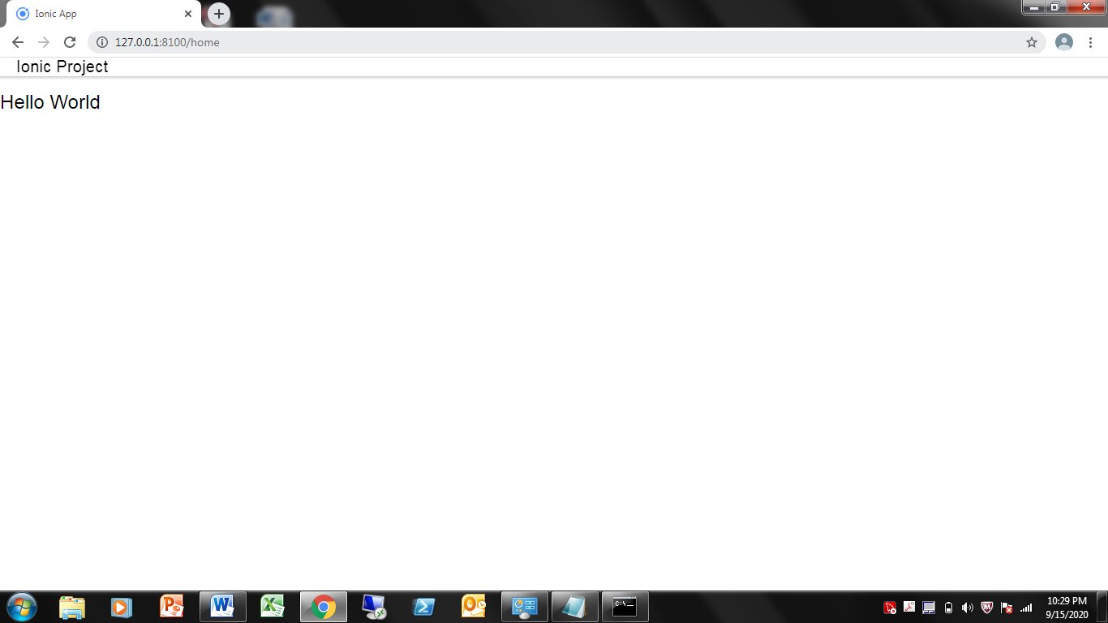

# How to create and Ionic Android app:

# Steps to create an ionic android app:

### After you have built the web app next command you should type is ionic cordova platform add android .This will add and android platform to your web app directory.

### 2. Now type ionic cordova build android to start building your android app.

### 3. Now type ionic cordova run android , If you have connect your machine to a phone and turned on USB debugging the app will export to your pc and if you are running an emulator the out will be like this.